Design Document and Screenshots

Until years is greater than zero display an error message and get and the number of years from the user.

Until current year is equal to total years

Until current month is equal to 12

Get rainfall in inches for the current month in the year from the user

Add current rainfall to total rainfall

Calculate total months by dividing total years by 12

Calculate average rainfall by dividing total rainfall by total months

Display the total number of months collected

Display the total amount of rainfall in inches

Display the average rainfall collected in inches.

*Compile Screenshot*

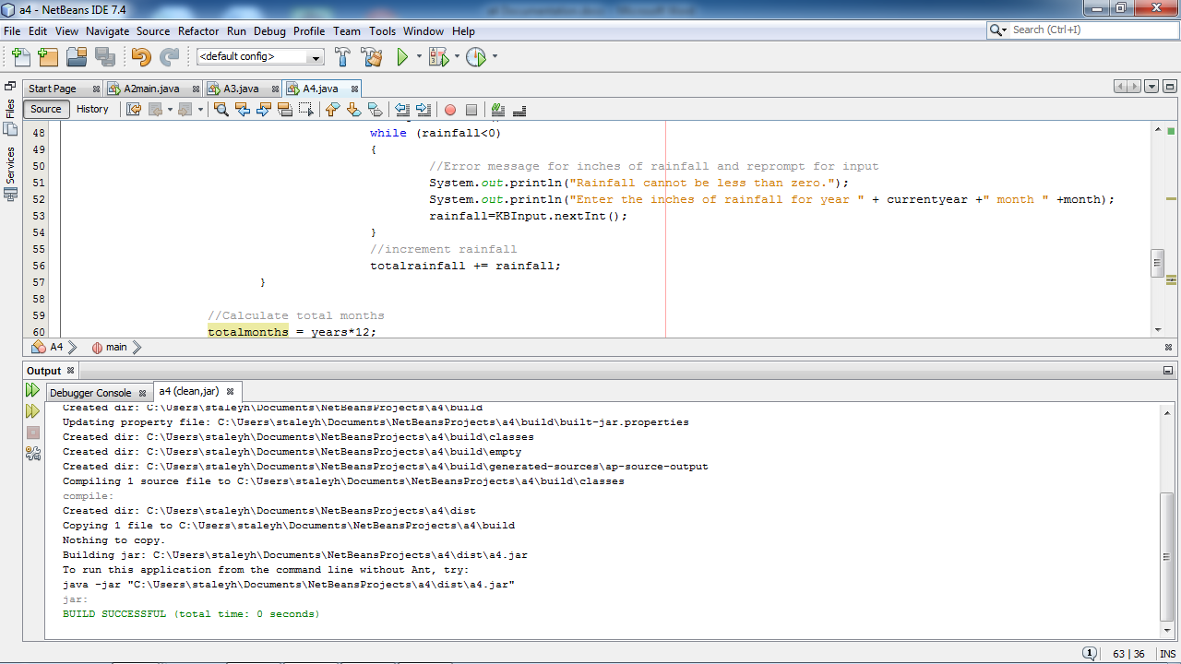

*Run Screenshot*

